Ques 1:

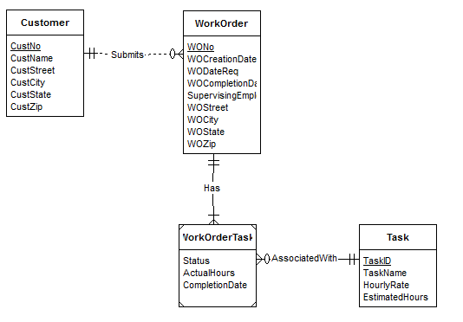

1. A customer may submit zero or more WorkOrders.
2. A WorkOrder must have at least one WorkOrder task.
3. A task may be associated with zero or more WorkOrdertasks.

Revised:

